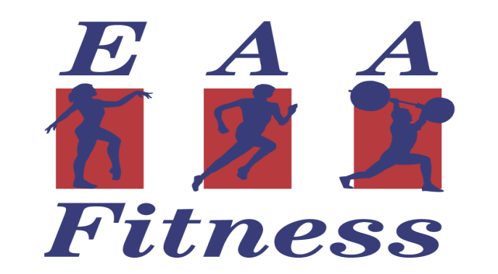

Welcome to the CMS "Fit for Life" Fitness Center! We are excited you have taken this step toward better health and we look forward to seeing you in the Center. To get you started with your fitness program, we need you to read and complete the information in this membership packet. Please complete all information as accurately as possible and return this packet to the Fitness Center on the lower level of the Central Building (CL-12-03).

Once we receive your information packet, we will complete the rest of the registration process and you may begin to utilize the Fitness Center. If you have any questions, please feel free to call us at 410-786-7873.

Yours in Good Health,
The "Fit For Life" Staff

PAYMENT OPTIONS (the Fitness Center accepts cash, Visa/MC, or check made payable to EAA):

- Annual ($265 – paid in full)

- Payroll Deduction ($25 down and $12 per pay – available only for CMS employees)

- Other___________________________________________________.

Name:
Age: Sex: M / F D.O.B.
Home Address:
City: State: Zip:
Home Phone: Work Phone:
Email Address:
In case of emergency call:__________ Phone: _
Please list all your Physician’s Name(s), Phone(s) and Address(s):

PAR-Q (circle yes or no)

Has your doctor ever said that you have a heart condition and that you should only YES NO
perform physical activity recommended by a doctor?
Do you feel pain in your chest when you perform physical activity? YES NO

In the past month, have you had chest pain when you were not performing any physical activity? YES NO

Do you lose your balance because of dizziness or do you ever lose consciousness? YES NO

Do you have a bone or joint problem that could be made worse by a change in your physical activity? YES NO

Is your doctor currently prescribing any medication for your blood pressure or for a heart condition? YES NO

Do you know of any other reason why you should not engage in physical activity? YES NO

Are you over the age of 54 and/or unaccustomed to vigorous exercise? YES NO

If you have answered “Yes” to one or more of the above questions, you will need to consult your physician before engaging in physical activity. After a medical evaluation, seek advice from your physician on what type of activity is suitable for your current condition.

RISK FACTORS

Do you have known elevated blood pressure (greater than 140/90)? YES NO

Do you have known elevated cholesterol levels? YES NO
(Total/HDL Ratio greater than 5.0 or Total greater than 200 ML/dl)

Do you have diabetes? YES NO
If so, what type and how is it treated:

Do you smoke? YES NO

Do you or have you had a bone, muscle or joint condition which might be aggravated by exercise? YES NO

Are you currently pregnant? YES NO
If yes, how far along?

Do you have other chronic illnesses, injury or disabilities that might affect your ability to exercise? If yes, please explain:

Please list any medications, Rx and non-Rx that you take on a regular basis:
NAME OF MEDICATION PURPOSE DOSAGE

When was your last thorough physical examination? Date:
Result:

What type of exercise have you done in the past?

The main reason(s) I want to exercise are:

INFORMED CONSENT AND RELEASE

I recognize that exercise is not without some risk to the musculoskeletal system (e.g. sprain, strain) and cardiorespiratory system (e.g. dizziness, fainting, abnormal heartbeat, discomfort in breathing, abnormal blood pressure response, and in rare instances, heart attack or stroke). I acknowledge that not all risks can be known in advance. I hereby certify that I know of no medical problems, except those listed within this questionnaire, that would increase my risk of illness or injury as a result of participation in exercise programs offered by the EAA Fitness Centers.

I understand that it is my responsibility to inform Fitness Center Staff members of any changes in my medical condition, including but not limited to, pregnancy. Upon notification to the Fitness Center Staff of a change in my medical condition, the staff will determine whether or not a change in my exercise program is warranted. I further understand that it is my responsibility to report immediately to a Fitness Center Staff member any signs or symptoms of discomfort and/or distress during or following an exercise program.

I consent to the administration of first aid, and resuscitative measures, by Fitness Center staff.

I hereby release and hold harmless the EAA Fitness Center, it’s agents, employees, and independent contractors from any and all liability, damage, expense, causes of action, suits, claims or judgments, arising from injury, damage or loss, or claims of injury, damage or loss to me or my personal property which may arise out of my use of the EAA Fitness Center facilities and/or their independent contractors. This release does not apply to acts of gross negligence performed by employees and/or contractors of EAA Fitness, resulting in direct injury to me.

I have read the entire Informed Consent and Release and accept the conditions stated herein as a requirement to participation in this program.

Signature Date

Witness (fitness staff)

