Drop It Like a Squat!
Different Types of Squats

You’ve been squatting since the day you learned to walk – it’s one of the most important and functional of all human movements.

Squats are one of the best exercises for building lower body strength and sculpting tight glutes, hamstrings, and quadriceps. They help improve pain-free mobility and flexibility by encouraging full extension and contraction throughout the hips. And, importantly, they build foundational strength for almost every movement you do on a daily basis.

As anyone who has ever done squats knows, they’re also pretty intense. It’s that intensity that makes them an excellent fat-burning exercise, because of their ability to stimulate the release of growth hormone and testosterone.

Squats can also improve your ability to run faster, jump higher, and perform any movement that involves lifting and bending. This is because they develop some of your body’s largest muscles, while also helping improve balance by strengthening the stability muscles that help keep you upright. Each focuses on improving overall lower body strength and mobility, while also targeting different areas of the glutes and legs to help you build your ideal physique.

Keep in mind that you always want to maintain proper form while squatting. Throughout each movement, be sure to keep your chest lifted and spine neutral (no rounding forward), your weight in your heels and your glutes pushed back.

Regular Squat
Level of difficulty: Beginner

The standard squat sets the foundation for all of the squat variations you’ll see here. It’s also one of the most basic functional movements humans use on a daily basis for sitting and picking things up.
Wall Squat
Level of difficulty: Beginner

The wall squat combines an isometric hold against a wall with the regular squat, which is an excellent option to work on your leg strength while still going easy on your knees.

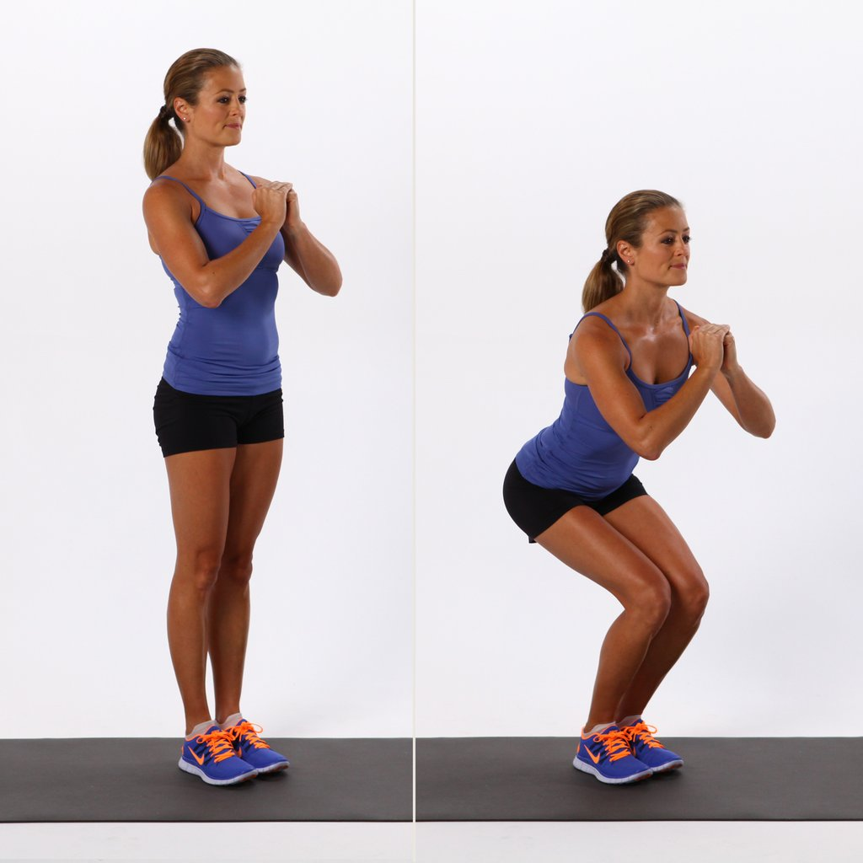
Narrow Stance Squat
Level of difficulty: Beginner

Narrow squats shorten your stance to put more emphasis on your quadriceps muscles as you squat down. It’s a great variation to add to your regular squat routine to hit a different area of the leg.

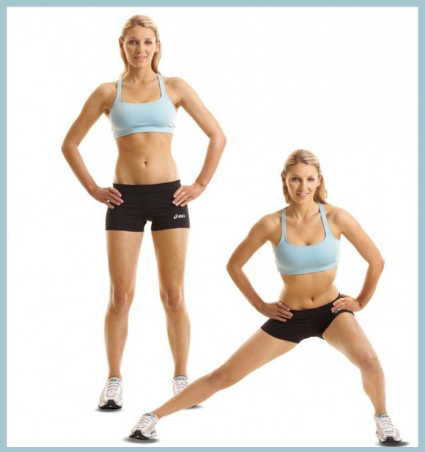
Lateral Squats
Level of difficulty: Beginner-intermediate

Lateral squats help increase flexibility through your groin muscles while simultaneously strengthening your adductors and core. This will help improve your mobility during day-to-day movements while sculpting lean legs.

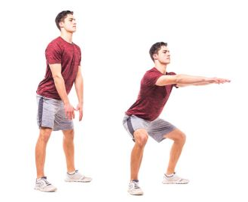
Sumo Squats
Level of difficulty: Beginner

Sumo squats are excellent for targeting your inner and outer thighs, which, especially in women, tend to hold on to excess fat. While it’s true you can’t reduce fat in one location, these squats will definitely help get your heart rate up to burn fat while you sculpt lean stems beneath.
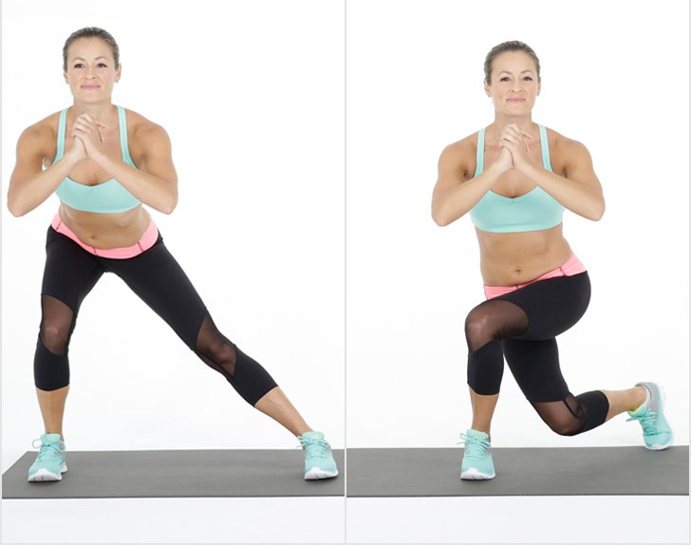
Curtsy Squats
Level of difficulty: Beginner

Curtsy squats shift focus to your inner and outer thighs, while also targeting your gluteus medius muscle that help give your bum that coveted lift.
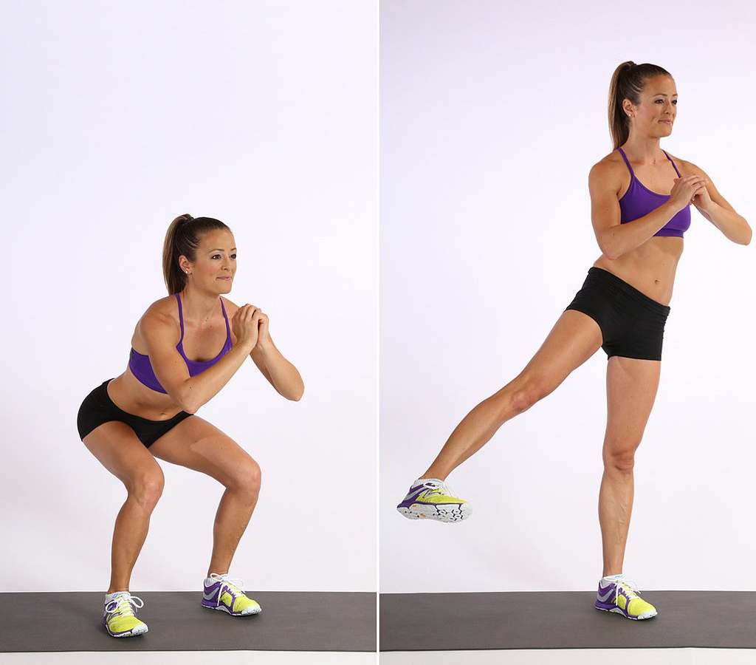
Squat with Leg Raise
Level of difficulty: Beginner

This squat variation is a triple threat that lifts and tones your glutes, hamstrings, and quads, sculpts your outer thighs, and gets your heart rate elevated to help burn off stubborn fat.

Jump Squats
Level of difficulty: Intermediate-advanced

There’s no burn like the burn you experience doing jump squats. These squats will tone your entire lower body in record time, while also melting fat and building explosive strength. This will improve your power during any movement, while also increasing your metabolic rate to burn more calories even at rest.

Prisoner Squats
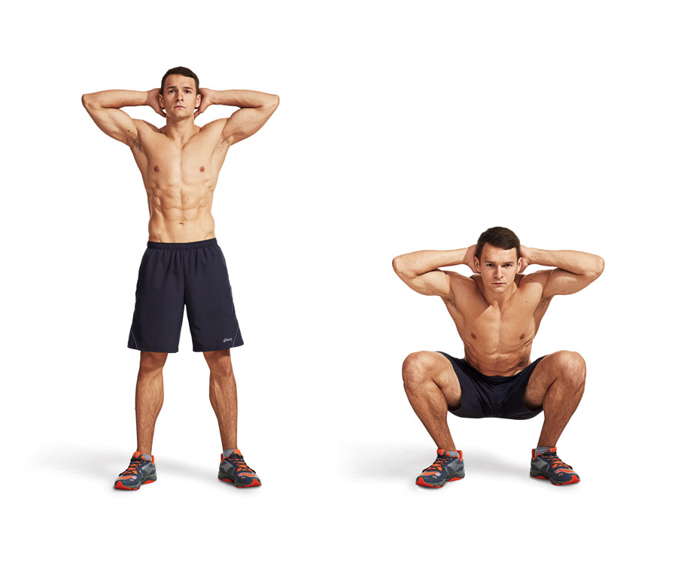
Level of difficulty: Beginner-intermediate

Prisoner squats are unique in that they not only work your entire lower body, but also help improve your posture by lengthening your spine and strengthening your core. The positioning of this exercise also helps you work on your stability as you sculpt and tone your glutes, making it a great two-benefits-in-one exercise. Just be sure to focus on keeping your elbows back and shoulder blades together throughout the movement so you keep your spine safe.
Plié Squats
Level of difficulty: Beginner-intermediate

Plié squats aren’t just for ballerinas. These squats will give you an intense inner thigh burn due to their wide stance, while also thoroughly engaging your glutes. Be sure to watch your knee alignment.

Box Squats
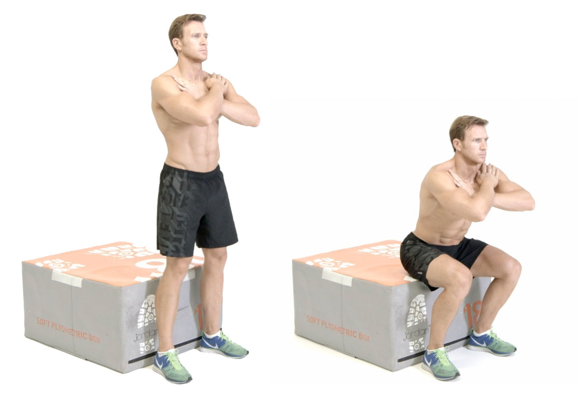
Level of difficulty: Beginner-intermediate

Box squats place more emphasis on the posterior, or backside, of the body, especially the lower back, glutes, and hamstrings. This is because you’re fully lowering onto the box and briefly touching it, which takes away the momentum you might use in a regular squat to “spring” back to standing. The result is a tighter backside, better balance, and better squat form.

Frog Squat
Level of difficulty: Beginner-intermediate

The wide and low stance of the frog squat is perfect for working deep into your glute muscles for a firm lift, while also working the inner thighs and hamstrings. They’re also great for improving your flexibility.

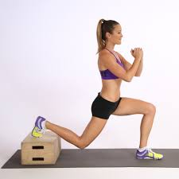
Bulgarian Split Squat
Level of difficulty: Intermediate

Bulgarian split squats allow you to get low and deep into your squat, which will help sculpt your entire leg and provide serious lift to your bum. Elevating one leg also increases your core strength.

Squat Walk
Level of difficulty: Beginner

The squat walk takes the burn of the wall squat hold to a new level. By staying low in a squat as you shuffle side-to-side, you strengthen and tone your entire lower body while also getting a deep burn in those glutes.
